**ASSEMBLY: Vertical Stirling Engine with Glass Dome**

**MOQ Assumed: 10,000 units**

1. **Standard:**

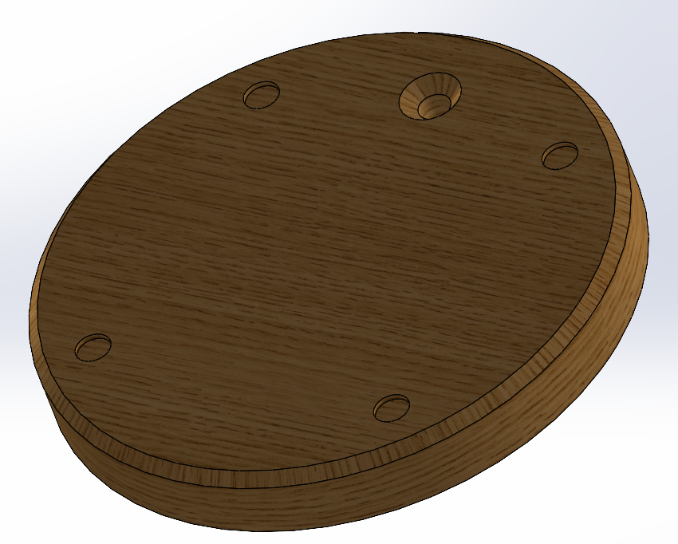

**Material:** Wood (Oak)

**Manufacturing Process:**

* **Lathe:** This is the most common method for creating perfectly round pieces. A wood blank is mounted on a rotating spindle and shaped using cutting tools.
* **Thickness is achieved by:**
* Using a parting tool to cut the desired thickness.
* Sanding to the desired thickness.

**Cost Analysis:**

* Material Cost: $2.85/kg * 0.52kg * 10,000 units = $14,820
* Machining Cost: $3.3/hr * 80hrs (assumed) = $264
* Labor Cost: $18/hr * 30 days = $18/hr * (30*8)hrs = $4,320

**Total Cost:** $14,820 + $264 + $4,320 = $19,404 for 10,000 units

= $1.94/unit

1. **Standard Shaft:**

**Material:** Wood (Oak)

**Manufacturing Process:**

* **Lathe:** This is the most common method for creating perfectly round pieces. A wood blank is mounted on a rotating spindle and shaped using cutting tools.
* **Machining:**
* Using a parting tool to cut the desired length at desired angle
* Sanding to creating level flat surfaces
* Drilling holes of diameter 4mm of desired 10mm and 7mm depth for screw threads
* Tap those same holes with M5 threads

**Cost Analysis:**

* Material Cost: $2.85/kg * 0.008kg * 10,000 units = $228
* Machining Cost: $5/hr * 32hrs (assumed) = $160
* Labor Cost: $18/hr * 7 days = $18/hr * (7*8)hrs = $1,008

**Total Cost:** $228 + $160 + $1,008 = $1396 for 10,000 units

= $0.1396/unit

1. **Base**

**Material:** Stainless Steel

**Manufacturing Process:**

* **Sheet Metal Fabrication**: Use a 6mm stainless steel sheet. Cut it using a die cutter of shape similar to 2D elliptical boundary of the part.
* **Machining:**
* Use machining tools to make required 11 counterbore/countersink holes

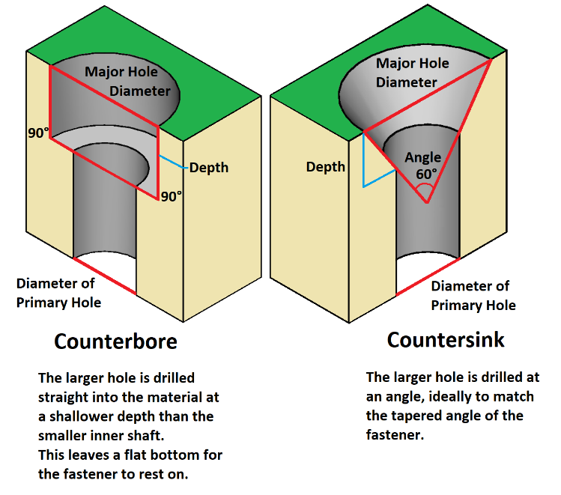

**Cost Analysis:**

* Material Cost: $1.5 * 0.107kg * 10,000 units = $1,605
* Manufacturing Cost: Die Cutting Cost + Machining Cost

= [$15/hr (assumed) * 10hrs] + [$23/hr * 3min/unit * 10,000 units] = $11,650

* Labor Cost: $18/hr * 600hrs = $10,800

**Total Cost:** $1,605 + $11,650 + $10,800 = $24,055 for 10,000 units = $2.4/unit

1. **Cylinder:**

**Material:** Brass

**Manufacturing Process:**

* **Pressure Die Casting**:
  + Purchase a custom die casting mold (specifically designed for above part) to be used in a die casting machine
  + Use mold in a die casting machine to produce 10,000 units
* **Machining:**
* Use a CNC machine to drill required tapped and thru holes according to the drawings
* Machine surfaces that determine CTF (critical to function) dimensions of the part

**Cost Analysis:**

* Material Cost: $9.17/kg (used from internet) * 0.138kg * 10,000 units = $12,654
* Manufacturing Cost: Die Casting Tooling Cost + Die Casting Cost + Machining Cost

= $20,000 + [$57/hr * 1min/unit * 10,000 units] + [$23/hr * 3min/unit * 10,000 units]= $41,000

* Labor Cost: $18/hr * 700hrs = $12,600

**Total Cost:** $12,654 + $41,000 + $12,600 = $66,254 for 10,000 units

= $6.62/unit

1. **Cylinder Cover**

**Material:** Stainless Steel

**Manufacturing Process:**

* **Pressure Die Casting**:
  + Purchase a custom die casting mold (specifically designed for above part) to be used in a die casting machine
  + Use mold in a die casting machine to produce 10,000 units
* **Machining:**
* Use a CNC machine or lathe to drill required thru holes according to the drawings

**Cost Analysis:**

* Material Cost: $1.5/kg (used from internet) * 0.021kg * 10,000 units = $315
* Manufacturing Cost: Die Casting Tooling Cost + Die Casting Cost + Machining Cost

= $10,000 + [$57/hr * 30sec/unit * 10,000 units] + [$23/hr * 60sec/unit * 10,000 units]= $18,584

* Labor Cost: $18/hr * 350hrs = $6,300

**Total Cost:** $315 + $18,584 + $6,300 = $25,199 for 10,000 units

= $2.52/unit

1. **Cylinder Head**

**Material:** Stainless Steel

**Manufacturing Process:**

* **Pressure Die Casting**:
  + Purchase a custom die casting mold (specifically designed for above part) to be used in a die casting machine
  + Use mold in a die casting machine to produce 10,000 units
* **Machining:**
* Use a CNC machine or lathe to drill required thru holes according to the drawings

**Cost Analysis:**

* Material Cost: $1.5/kg (used from internet) * 0.021kg * 10,000 units = $345
* Manufacturing Cost: Die Casting Tooling Cost + Die Casting Cost + Machining Cost

= $10,000 + [$57/hr * 30sec/unit * 10,000 units] + [$23/hr * 60sec/unit * 10,000 units]= $18,584

* Labor Cost: $18/hr * 350hrs = $6,300

**Total Cost:** $345 + $18,584 + $6,300 = $25,229 for 10,000 units

= $2.52/unit

1. **Support Link Holder**

**Material:** Stainless Steel

**Manufacturing Process:**

* **Pressure Die Casting**:
  + Purchase a custom die casting mold (specifically designed for above part) to be used in a die casting machine
  + Use mold in a die casting machine to produce 10,000 units
* **Machining:**
* Use a CNC machine or a lathe to drill required countersink holes according to the drawings

**Cost Analysis:**

* Material Cost: $1.5/kg (used from internet) * 0.008kg * 10,000 units = $120
* Manufacturing Cost: Die Casting Tooling Cost + Die Casting Cost + Machining Cost

= $8,000 + [$57/hr * 20sec/unit * 10,000 units] + [$23/hr * 45sec/unit * 10,000 units]= $14,041

* Labor Cost: $18/hr * 350hrs = $6,300

**Total Cost:** $120 + $14,041 + $6,300 = $20,461 for 10,000 units

= $2.05/unit

1. **Flowshaft**

**Material:** Stainless Steel

**Manufacturing Process:**

* **Pressure Die Casting**:
  + Purchase a custom die casting mold (specifically designed for above part) to be used in a die casting machine
  + Use mold in a die casting machine to produce 10,000 units
* **Machining:**
* Use a CNC machine or a lathe to drill required thru holes, rectangular recess area, and 5mm diameter hole along center of the shaft

**Cost Analysis:**

* Material Cost: $1.5/kg (used from internet) * 0.0172kg * 10,000 units = $258
* Manufacturing Cost: Die Casting Tooling Cost + Die Casting Cost + Machining Cost

= $12,000 + [$57/hr * 30sec/unit * 10,000 units] + [$23/hr * 90sec/unit * 10,000 units]= $22,500

* Labor Cost: $18/hr * 600hrs = $10,800

**Total Cost:** $258 + $22,500 + $10,800 = $33,558 for 10,000 units

= $3.35/unit

1. **Transfer Cylinder**

**Material:** Brass

**Manufacturing Process:**

* **Pressure Die Casting**:
  + Purchase a custom die casting mold (specifically designed for above part) to be used in a die casting machine
  + Use mold in a die casting machine to produce 10,000 units
* **Machining:**
* Use a 6-axis CNC machine to drill required tapped and thru holes according to the drawings
* Machine surfaces that determine CTF (critical to function) dimensions of the part

**Cost Analysis:**

* Material Cost: $9.17/kg (used from internet) * 0.05kg * 10,000 units = $5,043
* Manufacturing Cost: Die Casting Tooling Cost + Die Casting Cost + Machining Cost

= $10,000 + [$57/hr * 20sec/unit * 10,000 units] + [$23/hr * 30sec/unit * 10,000 units]= $15,083

* Labor Cost: $18/hr * 500hrs = $9,000

**Total Cost:** $5,043 + $15,083 + $9,000 = $29,126 for 10,000 units

= $2.92/unit

1. **Base Support**

**Material:** Brass

**Manufacturing Process:**

* **Machining:**
* Directly purchase 6mm thick sheet of Brass material
* Machine the sheet using milling tool to get desired 2D shape of the part
* Use drilling tools to tap 2 M3 holes and 1 4mm thru hole

**Cost Analysis:**

* Material Cost: $9.17/kg (used from internet) * 0.012kg * 10,000 units = $1,100
* Manufacturing Cost: Machining Cost

= [$23/hr * 30sec/unit * 10,000 units]= $1,917

* Labor Cost: $18/hr * 350hrs = $6,300

**Total Cost:** $1,100 + $1,917 + $6,300 = $9,317 for 10,000 units

= $0.94/unit

1. **Support Link**

**Material:** Copper Alloy

**Manufacturing Process:**

* **Sheet Metal Fabrication**:
  + Use a 2mm copper alloy sheet. Cut it using a die cutter of shape similar to 2D boundary of the part.
  + Develop a die cutting tool to cut all required holes at once
  + Use punching tool and use transfer press or progressive die

**Cost Analysis:**

* Material Cost: $9.71/kg * (0.004kg/0.75) * 10,000 units = $389
* Manufacturing Cost: Progressive Die Tool Setup Cost + Die Cutting Cost

= $8,000 (assumed) + [$23/hr * 1min/unit * 10,000 units] = $11,834

* Labor Cost: $18/hr * 200hrs = $3,600

**Total Cost:** $389 + $11,834 + $3,600 = $15,823 for 10,000 units = $1.59/unit

1. **Eccentric Sheave**

**Material:** Stainless Steel

**Manufacturing Process:**

* **Pressure Die Casting**:
  + Purchase a custom die casting mold (specifically designed for above part) to be used in a die casting machine
  + Use mold in a die casting machine to produce 10,000 units
* **Machining:**
* Use a CNC machine or a lathe to drill 1 thru hole and 1 tapped hole

**Cost Analysis:**

* Material Cost: $1.5/kg (used from internet) * 0.004kg * 10,000 units = $75
* Manufacturing Cost: Die Casting Tooling Cost + Die Casting Cost + Machining Cost

= $8,000 + [$57/hr * 10sec/unit * 10,000 units] + [$23/hr * 30sec/unit * 10,000 units]= $11,499

* Labor Cost: $18/hr * 130hrs = $2,340

**Total Cost:** $75 + $11,499 + $2,340 = $13,914 for 10,000 units

= $1.40/unit

1. **Flywheel**

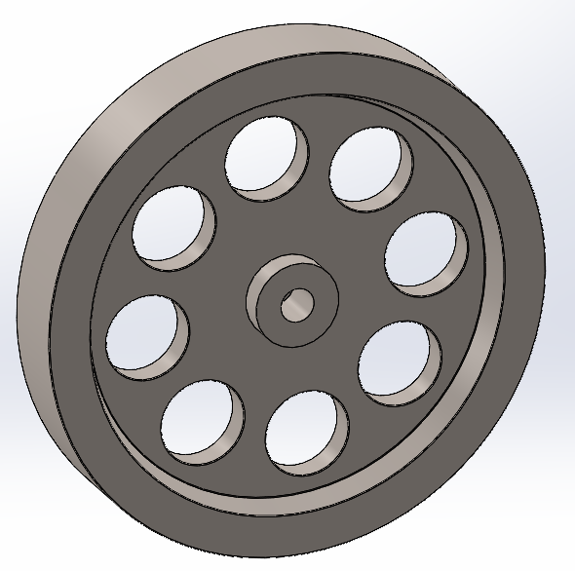

**Step 1: Choosing a stainless-steel alloy for flywheel considering following: -**

* Strength: Alloy should have adequate strength to withstand the mechanical stresses and loads experienced by the flywheel.
* Corrosion Resistance: Depending on the operating environment (e.g., marine, industrial), alloy should have corrosion resistance to ensure longevity and reliability of the flywheel.
* Machinability: Alloy should allow some machinability for additional machining operations required to produce final part.
* Cost: Need to balance the performance requirements with the cost of the stainless-steel alloy, including considerations for casting, machining, and any necessary post-processing treatments.

As this flywheel is part of an air engine, we can choose 316 stainless steel alloy

* Strength: Grade 316 stainless steel offers good strength properties suitable for high-speed applications. It has a tensile strength of around 580 MPa and a yield strength of about 290 MPa.
* Corrosion Resistance: Grade 316 is known for its excellent corrosion resistance, particularly in marine and chloride environments due to the addition of molybdenum. This makes it suitable for air engines that may be exposed to varying environmental conditions.
* Machinability: While not as easily machinable as some lower-alloyed stainless steels, Grade 316 can be machined effectively with appropriate tools and techniques.

**Step 2: Choosing a manufacturing process considering following: -**

As the shape of flywheel is unique, it will need some type of a mold in which molten stainless steel is poured and allowed for solidification. This process is called casting; there are multiple types of casting processes that can be considered for stainless steel: -

* Investment Casting (Lost Wax Casting):
  + Known for producing parts with excellent surface finish, intricate details, and tight tolerances.
  + Well-suited for stainless steel due to its ability to handle high melting temperatures and produce complex shapes.
* Sand Casting:
  + Versatile and can handle a wide range of sizes and shapes, making it suitable for large parts.
  + Can be used for 316 stainless-steel may require higher molding temperatures and careful handling to prevent oxidation.
* Shell Molding (Shell Casting):
  + Offers good dimensional accuracy, surface finish, and can handle higher production rates than traditional sand casting.
  + Can provide smoother surfaces and better dimensional control compared to sand casting.
* Die Casting (for certain stainless-steel alloys):
  + Can achieve high production rates and tight dimensional tolerances, suitable for mass production of smaller, more intricate parts.
  + Possible for stainless steel but less common due to the higher melting temperatures and more demanding process requirements.

Considering above casting options and taking into account their pros and cons, it would be beneficial to go ahead with investment casting. Sand casting would have been another good choice but it is comparatively a slower process and is more suitable for limited size batch production and less suitable for high volume production. Assuming that flywheel (part of air engine) would be a high volume part, sand casting would not be a good choice. Finally, for die casting, given the high costs and technical challenges associated with die casting stainless steel, this method is rarely used in practice. Therefore, investment casting seems to be the best feasible choice considering high melting point of 316 stainless steel (~1399°C).

**Step 3: Investment Die Casting Process Flow: -**

1. **Pattern Creation:** A wax pattern is made, replicating the final product's shape. These patterns are typically produced using injection molding.
2. **Pattern Assembly:** The wax patterns are attached to a central wax gating system (sprue) to form a tree-like assembly. This allows multiple parts to be cast in a single mold.
3. **Shell Building:** The wax assembly is repeatedly dipped into a ceramic slurry and coated with fine sand (stucco) to build a ceramic shell around the wax pattern. This process is repeated several times to achieve the desired thickness and strength of the shell.
4. **Wax Removal:** The ceramic-coated wax assembly is placed in an autoclave or furnace to melt and drain out the wax, leaving a hollow ceramic shell. This step is also known as dewaxing.
5. **Preheating:** The ceramic shell is preheated to remove any residual wax and moisture, and to prepare it for the molten metal. This also strengthens the ceramic mold.
6. **Pouring:** Molten metal (such as 316 stainless steel) is poured into the preheated ceramic shell through the gating system. The high temperature ensures that the metal fills all intricate details of the mold.
7. **Cooling:** The molten metal is allowed to cool and solidify within the ceramic mold.
8. **Shell Removal:** The ceramic shell is broken away using mechanical vibration, water jets, or chemical processes to reveal the metal casting.
9. **Cutting and Finishing:** The individual cast parts are cut from the central gating system. The castings are then cleaned, ground, and machined as needed to meet final specifications.
10. **Inspection:** The finished parts undergo inspection for quality assurance, including dimensional checks and non-destructive testing methods to detect any defects.

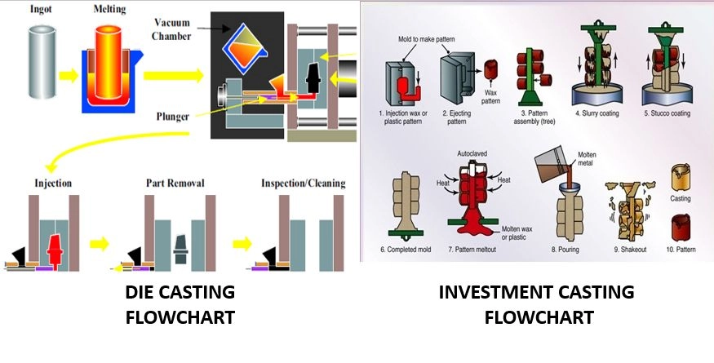

**Step 4: Quality Assurance and Inspection: -**

Inspecting critical-to-function dimensions of a flywheel is essential to ensure its performance, safety, and reliability in its application. The inspection process typically involves several steps and uses a variety of measurement techniques. Here’s a detailed overview:

1. Visual Inspection

* Purpose: Identify any obvious defects or irregularities.
* Methods: Check for cracks, surface imperfections, and overall condition of the flywheel. Use magnification if needed to inspect small details.

1. Dimensional Inspection

* Purpose: Verify that all critical dimensions are within specified tolerances.
* Tools and Methods:
* Calipers and Micrometers: Measure diameter, thickness, and other critical dimensions. Ensure accuracy within tight tolerances.
* Gages and Fixtures: Use specialized gages and fixtures to measure features like keyways, mounting holes, and balancing surfaces.
* Coordinate Measuring Machine (CMM): Provides high precision for complex geometries and can measure multiple dimensions in one setup.

1. Balancing Inspection
   * Purpose: Ensure the flywheel is properly balanced to avoid vibrations during operation.
   * Methods:
     + Dynamic Balancing: Use a balancing machine to check and correct any imbalance. This is critical for flywheels to ensure smooth operation and reduce wear on connected components.
2. Surface Finish Inspection
   * Purpose: Confirm that surface finishes meet requirements for function and longevity.
   * Methods:
     + Surface Roughness Tester: Measure surface texture to ensure it meets specified roughness values. Important for areas that come into contact with other components or require a specific finish.
3. Geometric Inspection
   * Purpose: Verify that geometric features like concentricity, runout, and flatness are within tolerance.
   * Tools and Methods:
     + Dial Indicators: Check for runout and concentricity of the flywheel’s rotational axis.
     + Flatness Gages: Measure the flatness of surfaces to ensure proper fit and function.
4. Material Inspection
   * Purpose: Ensure that the flywheel material meets the required specifications and properties.
   * Methods:
     + Hardness Testing: Verify material hardness to ensure it meets strength requirements.
     + Non-Destructive Testing (NDT): Techniques like ultrasonic testing or magnetic particle inspection to detect internal flaws or defects.
5. Functional Testing
   * Purpose: Ensure the flywheel performs correctly under operational conditions.
   * Methods:
     + Operational Testing: Mount the flywheel on a test rig or engine to check its performance under simulated operating conditions.
     + Dynamic Testing: Evaluate the flywheel’s behavior during dynamic loading and operation to ensure it performs as expected.

**Step 5: Documentation and Reporting: -**

* Recording Measurements: Document all measurements, test results, and inspection findings. Ensure traceability to the specific flywheel and its manufacturing lot.
* Quality Control Reports: Prepare detailed reports summarizing the inspection process, results, and any corrective actions taken.
* Proper inspection of critical dimensions ensures that the flywheel will function reliably and meet safety and performance standards. Regular and thorough inspections help in maintaining high-quality standards and preventing issues in operation.

**Cost Analysis**

Let's assume the following data for a flywheel production:

MOQ (Minimum Order Quantity) = 10,000 units

#### Material Costs

* **Material Required**: (0.111 kg/unit * 10,000) * 1.1 = 1221kg
  + **Note**: Added 10% extra material for buffer/wastage
* **Material Cost per kg**: $7.72 per kg
* **Total Material Cost**: 1221kg * $7.72/kg = $9,426

#### Labor Costs

Assuming team of 10 production team members are required to support this production for a duration of 3 months. Considering 25 working days per month.

* **Labor Hours**: 25days/month * 3months * 8 hours/day * 10 workers = 6000 man-hours
* **Labor Rate**: $25 per hour
* **Total Labor Cost**: 6000 man-hours * $25/hour = $150,000

#### Machine Time Costs

Assuming half of man hours are consumed in machine operations.

* **Machine Hours**: 3000 hours
* **Machine Rate**: $32 per hour
* **Total Machine Time Cost**: 3000hours * $32/hour = $96,000

### Total Costs

* **Total Direct Costs**:

Total Direct Costs = Total Material Cost + Total Labor Cost = $159,426

* **Total Overhead Costs**:

Total Overhead Costs = Total Machine Time Cost = $96,000

* **Total Cost**:

Total Cost = Total Direct Costs + Total Overhead Costs = $255,426

Total Cost per unit = $255,426 / 10,000 = $25.54/unit

This analysis provides a basic overview. Additional factors would be considered in detailed cost analysis like quality control, setup costs, and other overheads that may affect the total cost.

**Crankrod 1**

**Material:** Copper Alloy

**Manufacturing Process:**

* **Sheet Metal Fabrication**:
  + Use a 2mm copper alloy sheet. Cut it using a die cutter of shape similar to 2D boundary of the part along with 2 thru holes

**Cost Analysis:**

* Material Cost: $9.71/kg * (0.002kg/0.75) * 10,000 units = $259
* Manufacturing Cost: Progressive Die Tool Setup Cost + Die Cutting Cost

= $3,000 (assumed) + [$23/hr * 5sec/unit * 10,000 units] = $3,319

* Labor Cost: $18/hr * 50hrs = $900

**Total Cost:** $259 + $3,319 + $900 = $4,478 for 10,000 units = $0.45/unit

1. **Crankrod 2**

**Material:** Copper Alloy

**Manufacturing Process:**

* **Sheet Metal Fabrication**:
  + Use a 2mm copper alloy sheet. Cut it using a die cutter of shape similar to 2D boundary of the part along with 2 thru holes

**Cost Analysis:**

* Material Cost: $9.71/kg * (0.002kg/0.75) * 10,000 units = $259
* Manufacturing Cost: Progressive Die Tool Setup Cost + Die Cutting Cost

= $3,000 (assumed) + [$23/hr * 5sec/unit * 10,000 units] = $3,319

* Labor Cost: $18/hr * 50hrs = $900

**Total Cost:** $259 + $3,319 + $900 = $4,478 for 10,000 units = $0.45/unit

1. **Crankrod Bolt 1**

**Material:** Brass

**Manufacturing Process:**

* **Pressure Die Casting**:
  + Purchase a custom die casting mold (specifically designed for above part) to be used in a die casting machine
  + Use mold in a die casting machine to produce 10,000 units
* **Machining:**
* Machine surfaces that determine CTF (critical to function) dimensions of the part

**Cost Analysis:**

* Material Cost: $9.17/kg (used from internet) * 0.005kg * 10,000 units = $458
* Manufacturing Cost: Die Casting Tooling Cost + Die Casting Cost + Machining Cost

= $1,000 + [$57/hr * 5sec/unit * 10,000 units] + [$23/hr * 5sec/unit * 10,000 units]= $1,202

* Labor Cost: $18/hr * 30hrs = $540

**Total Cost:** $92 + $1,202 + $540 = $2,200 for 10,000 units

= $0.22 /unit

1. **Crankrod Bolt 2**

**Material:** Copper

**Manufacturing Process:**

* **Pressure Die Casting**:
  + Purchase a custom die casting mold (specifically designed for above part) to be used in a die casting machine
  + Use mold in a die casting machine to produce 10,000 units
* **Machining:**
* Machine surfaces that determine CTF (critical to function) dimensions of the part

**Cost Analysis:**

* Material Cost: $9.71/kg (used from internet) * 0.001kg * 10,000 units = $97
* Manufacturing Cost: Die Casting Tooling Cost + Die Casting Cost + Machining Cost

= $1,000 + [$57/hr * 5sec/unit * 10,000 units] + [$23/hr * 5sec/unit * 10,000 units]= $1,202

* Labor Cost: $18/hr * 30hrs = $540

**Total Cost:** $97 + $1,202 + $540 = $1,839 for 10,000 units

= $0.19 /unit

1. **Piston Rod**

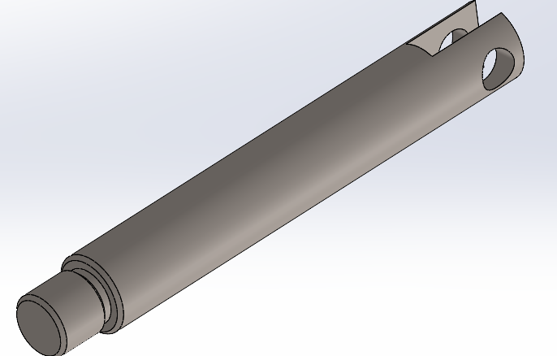

**Material:** Stainless Steel

**Manufacturing Process:**

* **Lathe:** This is the most common method for creating perfectly round pieces. A stainless steel blank is mounted on a rotating spindle and shaped using cutting tools.
* **Machining:**
* Using a parting tool to cut the desired length
* Use drilling and threading tools to form threads, slot and thru hole and shown above

**Cost Analysis:**

* Material Cost: $1.5/kg * 0.005kg * 10,000 units = $75
* Machining Cost: $13/hr * 1/min/unit (assumed) * 10,000 units = $2,167
* Labor Cost: $18/hr * 180 = $3,240

**Total Cost:** $75 + $2,167 + $3,240 = $5,482 for 10,000 units

= $0.55/unit

1. **Piston Stud**

**Material:** Copper

**Manufacturing Process:**

* **Lathe:** This is the most common method for creating perfectly round pieces. A copper blank is mounted on a rotating spindle and shaped using cutting tools.
* **Machining:**
* Using a parting tool to cut the desired length

**Cost Analysis:**

* Material Cost: $9.71/kg * 0.0002kg * 10,000 units = $19
* Machining Cost: $13/hr * 30 sec/unit (assumed) * 10,000 units = $1,084
* Labor Cost: $18/hr * 90 hrs = $1,620

**Total Cost:** $97 + $1,084 + $1,620 = $2,723 for 10,000 units

= $0.27/unit

1. **Link Bushing**

**Material:** Brass

**Manufacturing Process:**

* **Lathe:** This is the most common method for creating perfectly round pieces. A brass blank is mounted on a rotating spindle and shaped using cutting tools.
* **Machining:**
* Use milling tool to create long hollow tube
* Using a parting tool to cut the desired length

**Cost Analysis:**

* Material Cost: $9.17/kg * 0.0005kg * 20,000 units = $92
* Machining Cost: $13/hr * 30 sec/unit (assumed) * 20,000 units = $2,168
* Labor Cost: $18/hr * 180 hrs = $3,240

**Total Cost:** $92 + $2,168 + $3,240 = $5,592 for 20,000 units

= $0.27/unit

1. **Piston**

**Material:** Alloy Steel

**Manufacturing Process:**

* **Lathe:** This is the most common method for creating perfectly round pieces. A steel blank is mounted on a rotating spindle and shaped using cutting tools.
* **Machining:**
* Using a parting tool to cut the desired thickness
* Use milling tool to form axisymmetric 2D shape according to drawing

**Cost Analysis:**

* Material Cost: $1.5/kg * 0.011kg * 10,000 units = $165
* Machining Cost: $13/hr * 30 sec/unit (assumed) * 10,000 units = $1,084
* Labor Cost: $18/hr * 90 hrs = $1,620

**Total Cost:** $165 + $1,084 + $1,620 = $2,869 for 10,000 units

= $0.29/unit

1. **Inner Heater Dome**

**Material:** Glass

**Manufacturing Process:**

* **Blow Molding:** Manufacturing process where a liquid or pliable material is shaped into a desired form within a cavity by blowing air to push glass against the cavity for forming a certain shape.
* **Surface Finishing:**
* Polish the glass surface to achieve the desired roughness values.

**Cost Analysis:**

* Material Cost: $2.1/kg * 0.003kg * 10,000 units = $63
* Blow Molding Cavity Development Cost: $20,000
* Blow Molding Process Cost: [$75/hr * 5min/unit * 10,000 units] = $62,500
* Labor Cost: $18/hr * 900 hrs = $16,200

**Total Cost:** $63 + $20,000 + $62,500 + 16,200 = $98,763 for 10,000 units

= $9.88/unit

1. **Outer Heater Dome**

**Material:** Glass

**Manufacturing Process:**

* **Blow Molding:** Manufacturing process where a liquid or pliable material is shaped into a desired form within a cavity by blowing air to push glass against the cavity for forming a certain shape.
* **Surface Finishing:**
* Polish the glass surface to achieve the desired roughness values.

**Cost Analysis:**

* Material Cost: $2.1/kg * 0.013kg * 10,000 units = $273
* Blow Molding Cavity Development Cost: $20,000
* Blow Molding Process Cost: [$75/hr * 7min/unit * 10,000 units] = $87,500
* Labor Cost: $18/hr * 900 hrs = $16,200

**Total Cost:** $273 + $20,000 + $87,500 + 16,200 = $123,931 for 10,000 units

= $12.39/unit

1. **Connecting Link**

**Material:** Copper Alloy

**Manufacturing Process:**

* **Sheet Metal Fabrication**:
  + Use a 2mm copper sheet. Cut it using a die cutter of shape similar to 2D boundary of the part.
  + Develop a die cutting tool to cut all required holes at once
  + Use die cutting tool and use transfer press or progressive die

**Cost Analysis:**

* Material Cost: $9.71/kg * (0.003kg/0.75) * 20,000 units = $389
* Manufacturing Cost: Progressive Die Tool Setup Cost + Die Cutting Cost

= $8,000 (assumed) + [$23/hr * 1min/unit * 20,000 units] = $11,834

* Labor Cost: $18/hr * 400hrs = $3,600

**Total Cost:** $778 + $23,668 + $7,200 = $31,646 for 20,000 units = $1.59/unit

1. **Connecting Link Stud**

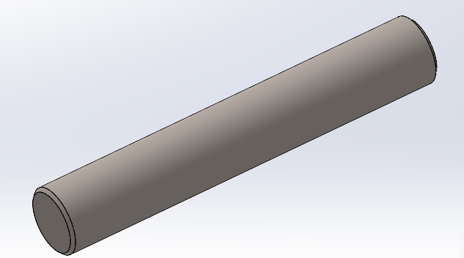

**Material:** Stainless Steel

**Manufacturing Process:**

* **Lathe:** This is the most common method for creating perfectly round pieces. A stainless steel blank is mounted on a rotating spindle and shaped using cutting tools.
* **Machining:**
* Using a parting tool to cut the desired length

**Cost Analysis:**

* Material Cost: $1.5/kg * 0.0001kg * 10,000 units = $1.5
* Machining Cost: $13/hr * 30sec/unit (assumed) * 10,000 units = $1,083
* Labor Cost: $18/hr * 90 = $1,620

**Total Cost:** $1.5 + $1,083 + $1,620 = $2,704 for 10,000 units

= $0.27/unit

1. **Support Link Stud**

**Material:** Stainless Steel

**Manufacturing Process:**

* **Lathe:** This is the most common method for creating perfectly round pieces. A stainless steel blank is mounted on a rotating spindle and shaped using cutting tools.
* **Machining:**
* Using a parting tool to cut the desired length

**Cost Analysis:**

* Material Cost: $1.5/kg * 0.0002kg * 10,000 units = $3
* Machining Cost: $13/hr * 30sec/unit (assumed) * 10,000 units = $1,083
* Labor Cost: $18/hr * 90 = $1,620

**Total Cost:** $15 + $1,083 + $1,620 = $2,706 for 10,000 units

= $0.27/unit

1. **Crosshead**

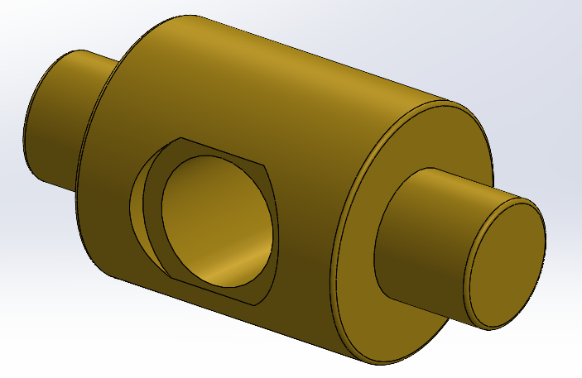

**Material:** Brass

**Manufacturing Process:**

* **Lathe:** This is the most common method for creating perfectly round pieces. A brass blank is mounted on a rotating spindle and shaped using cutting tools. Use drilling tool to for tapped hole at the center of the shaft

**Cost Analysis:**

* Material Cost: $9.17/kg (used from internet) * 0.002kg * 10,000 units = $184
* Manufacturing Cost: Lathe Machining Cost

= [$13/hr * 60sec/unit * 10,000 units] = $2,167

* Labor Cost: $18/hr * 200hrs = $3,600

**Total Cost:** $184 + $2,167 + $3,600 = $5,951 for 10,000 units

= $0.59/unit

1. **Transfer Piston Rod**

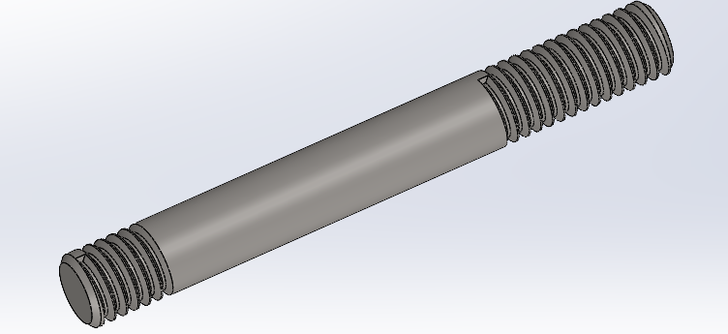

**Material:** Stainless Steel

**Manufacturing Process:**

* **Lathe:** This is the most common method for creating perfectly round pieces. A stainless steel blank is mounted on a rotating spindle and shaped using cutting tools.
* **Machining:**
* Using a parting tool to cut the desired length
* Use threading tools to form threads

**Cost Analysis:**

* Material Cost: $1.5/kg * 0.001kg * 10,000 units = $15
* Machining Cost: $13/hr * 30 sec/unit (assumed) * 10,000 units = $1,083
* Labor Cost: $18/hr * 90 = $1,620

**Total Cost:** $15 + $1,083 + $1,620 = $2,718 for 10,000 units

= $0.27/unit

1. **Transfer Piston**

**Material:** Stainless Steel

**Manufacturing Process:**

* **Lathe:** This is the most common method for creating perfectly round pieces. A stainless steel blank is mounted on a rotating spindle and shaped using cutting tools.
* **Machining:**
* Use milling cutter to form a cavity like space
* Use a drilling tool for countersink hole at the center

**Cost Analysis:**

* Material Cost: $1.5/kg * 0.008kg * 10,000 units = $135
* Machining Cost: $13/hr * 1min/unit (assumed) * 10,000 units = $2,167
* Labor Cost: $18/hr * 180 = $3,240

**Total Cost:** $135 + $2,167 + $3,240 = $5,542 for 10,000 units

= $0.55/unit

1. **Flowshaft Bolt**

**Material:** Stainless Steel

**Manufacturing Process:**

* **Pressure Die Casting**:
  + Purchase a custom die casting mold (specifically designed for above part) to be used in a die casting machine
  + Use mold in a die casting machine to produce 10,000 units
* **Machining:**
* Use a CNC machine or a lathe to drill 1 thru hole at the center

**Cost Analysis:**

* Material Cost: $1.5/kg (used from internet) * 0.001kg * 10,000 units = $15
* Manufacturing Cost: Die Casting Tooling Cost + Die Casting Cost + Machining Cost

= $8,000 + [$57/hr * 15sec/unit * 10,000 units] + [$23/hr * 15sec/unit * 10,000 units]= $11,333

* Labor Cost: $18/hr * 100hrs = $1,800

**Total Cost:** $15 + $11,333 + $1,800 = $13,148 for 10,000 units

= $1.31/unit

1. **Tube**

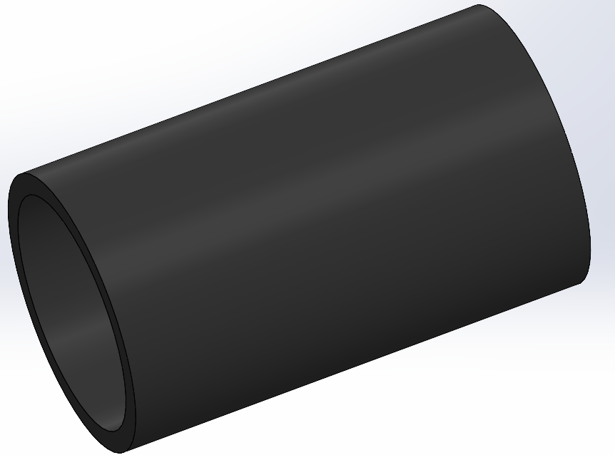

**Material:** Tube

**Manufacturing Process:**

* **Extrusion:** Rubber extrusion involves compounding rubber, feeding it into an extruder, heating it, forcing it through a shaped die, curing the extruded rubber, and finally cutting and finishing the product to desired specifications.
* **Machining:** Cut the long hollow rubber tube at desired lengths

**Cost Analysis:**

* Material Cost: $3/kg * 0.0001kg * 10,000 units = $3
* Extrusion Tool Development Cost: $2,000
* Extrusion + Machining Process Cost: [$15/hr * 10sec/unit * 10,000 units] = $416
* Labor Cost: $18/hr * 28 hrs = $504

**Total Cost:** $30 + $2,000 + $416 + $504 = $2,923 for 10,000 units

= $0.30/unit